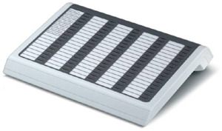
OpenStage Busy Lamp Field 40

